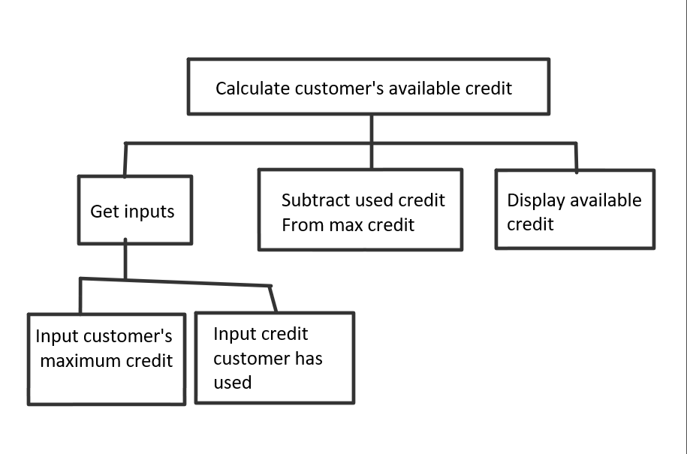

**2.**

/*-----------------------------------------------------------------

*Program Name: AccountBalance.cpp

*Description: Calculate the current account balance

With input received about starting

Balance deposits and withdrawals

*Programmer Name: Cameron Hattendorf

*Date: 1/26/2020

*-----------------------------------------------------------------*/

Input

Ask the user for starting balance;

Receive input for the starting balance;

Ask user for total dollar amount of deposits made;

Receive input for total dollar amount of deposits made;

Ask user for total dollar amount of withdrawals made;

Recieve input for total dollar amount of withdrawals made;

Process

Calculate the current balance by adding deposit amount to the starting balance, then

subtracting the withdrawals;

Output

Display the current balance;

**3.**

/*-----------------------------------------------------------------

*Program Name: SalesTax.cpp

*Description: Calculate the sales tax of an item

Being purchased

*Programmer Name: Cameron Hattendorf

*Date: 1/26/2020

*-----------------------------------------------------------------*/

Input

Ask for the retail price of the item being purchased;

Receive input for the retail price of the item being purchased;

Ask for the sales tax rate as a “percent” (double);

Receive input for the retail price of the item being purchased;

Process

Calculate the total sale by multiplying the sales tax variable by 1.01 then multiplying the

product by the retail price of the item being purchased;

Output

Display the total of the sale;